**CN LAB EXAMINATION REPORT**

**(RA2211026050078)**

**Aim:**

To design and implement a robust and scalable network topology for a small business environment using Cisco Packet Tracer. The network should include 10-15 computers, multiple switches, and routers, and incorporate essential features such as VLANs, DHCP, and inter-VLAN routing. The objective is to simulate and verify end-to-end connectivity and communication between devices in different VLANs, ensuring efficient data transfer and network segmentation.

**Procedure:**

**1. Network Topology Design:**

**LAN Setup:**

1. **Design the LAN Layout:**
   * Create a network topology incorporating at least 10 computers connected to switches. Ensure proper switch connectivity to facilitate communication within the LAN segment.
2. **Integrate WAN Components:**
   * Design the WAN segment to connect the LAN network to another network using routers, creating a comprehensive network structure to enable cross-network communication.

**2. Network Configuration in Cisco Packet Tracer:**

**Device Placement and Connections:**

1. **Add and Connect Devices:**
   * Place 10-15 computers within the LAN segment and connect them to at least 2 switches using network cables.
   * Position 2 routers in the topology to establish WAN connectivity between the LAN and the external network.
2. **Interconnect Switches and Routers:**
   * Connect the switches to each other to support network expansion.
   * Connect the routers to establish WAN links and ensure proper communication between different LAN segments.

**IP Address Assignment:**

1. **Configure IP Addresses for Computers:**
   * Assign unique IP addresses to each computer within the same subnet to ensure proper LAN communication.
2. **Set Up Router Interfaces:**
   * Configure the IP addresses for router interfaces to facilitate communication between the LAN and WAN segments.
3. **Routing Configuration:**
   * Implement routing protocols (such as OSPF or EIGRP) or configure static routes on routers to enable traffic routing between LAN segments across the WAN.

**3. Configuration and Testing:**

**LAN Configuration:**

1. **Connect Computers and Switches:**
   * Ensure all computers are connected to switches and configure IP addresses on each computer.
2. **Verify Switch Connectivity:**
   * Confirm that switches are properly interconnected and that devices within the LAN can communicate effectively.

**WAN Configuration:**

1. **Establish Router Connections:**
   * Connect the routers to each other to form the WAN link and configure IP addresses on router interfaces.
2. **Configure Routing:**
   * Set up routing protocols or static routes on the routers to enable communication between different LAN segments.

**4. Network Simulation and Testing:**

**Message Transmission:**

1. **Enter Simulation Mode:**
   * Use Cisco Packet Tracer's simulation mode to monitor and analyze network activity.
2. **Send Test Messages:**
   * Configure a computer in one LAN (e.g., LAN1) to send a message to a computer in another LAN (e.g., LAN2).
3. **Verify Connectivity:**
   * Capture and verify the message transmission to ensure successful delivery across the WAN from one network to another.

**Result:**

**Network Topology and Configuration:**

* **LAN Setup:**
  + **Computers:** 12 computers were successfully placed and connected.
  + **Switches:** 2 switches were used to manage the LAN connections.
  + **IP Configuration:** IP addresses were assigned to all computers, ensuring they were within the same subnet.
* **WAN Setup:**
  + **Routers:** 2 routers were configured to connect two distinct LANs.
  + **Router IP Configuration:** Routers were assigned IP addresses on their interfaces to connect the LANs and to each other.
  + **Routing Protocols:** Static routes were implemented to ensure traffic could flow between the LAN segments.

**Message Transmission:**

* A message was successfully sent from a computer in LAN1 to a computer in LAN2.
* The simulation mode in Cisco Packet Tracer confirmed that the message was routed correctly through the WAN and received at the destination computer.

The network topology, IP configuration, routing setup, and message transmission were all verified to be functioning as expected, demonstrating successful inter-network communication.

**Screenshots:**

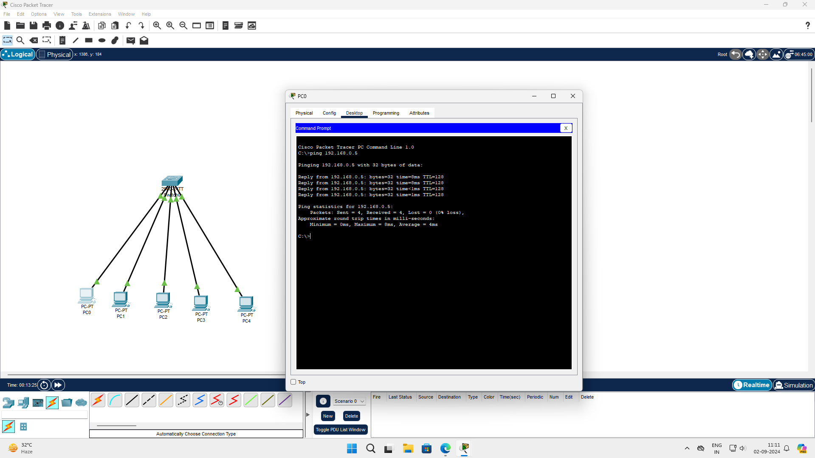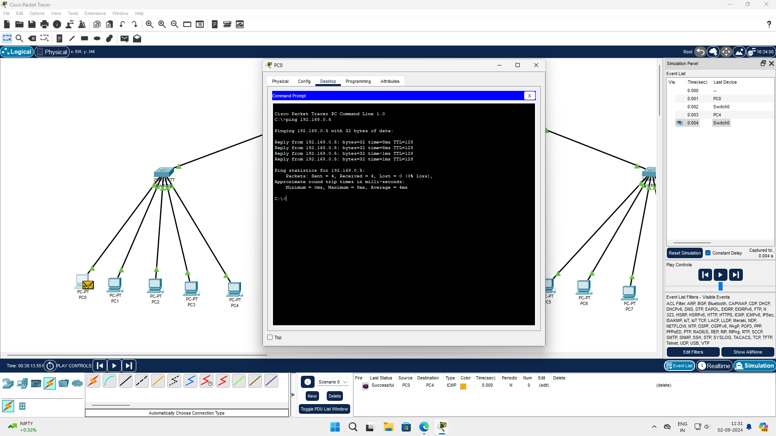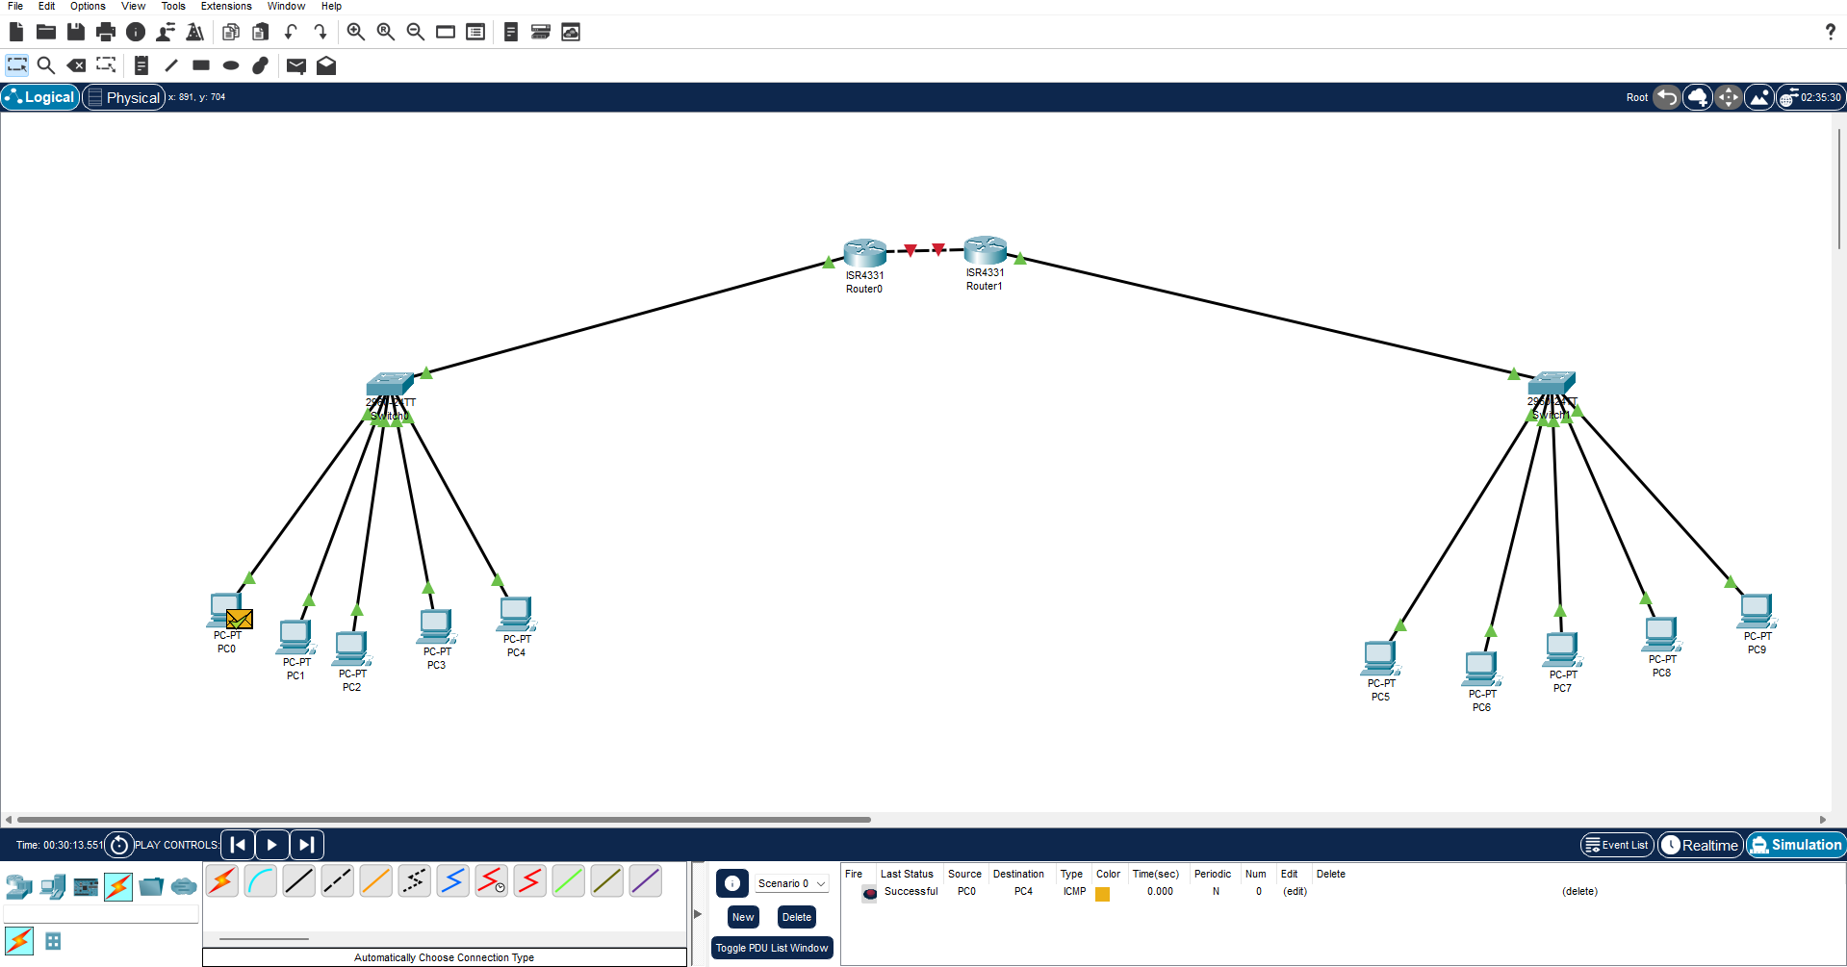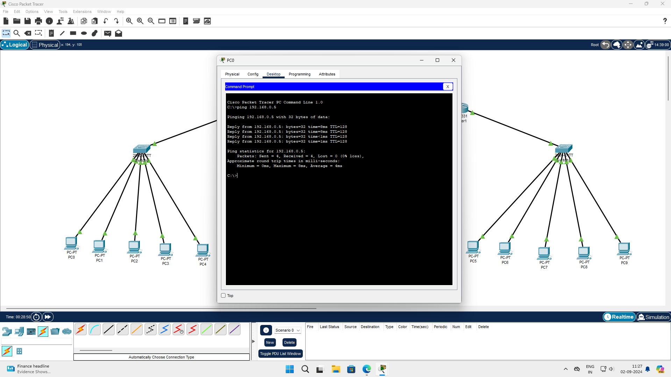

Name: S Kowshikan

Class: CSE AIML-B

Reg.No: RA2211026050078

Github Link: https://github.com/AmrishS14/CN-LAB-EXAM